标准配置和选项 Standard and Optional Equipment
特点 Features
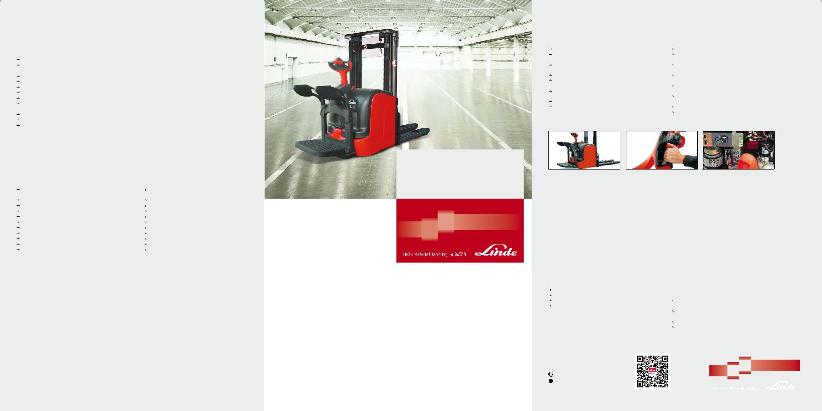

标准配置 Standard Equipment

林德载荷控制器(LLC)比例控制门架提升、下降的速度货叉软着陆功能：货叉着陆前自动减速(与林德载荷控制器 (LLC) 配合作用)

电子伺服转向(林德电子转向系统LES)林德交流数字控制器(LAC)
自动制动功能(林德制动控制LBC)橡胶驱动轮带防护架的聚氨酯双承载轮

聚氨酯双稳定轮

货叉长度1150mm
货叉外间距560mm
。
-10 C冷库保护

电池电缆和插头

Proportional control of lifting and lowering motions by LLC

Soft landing by reducing fork carriage speed when lowering to floor (in conjunction with LLC)
Active electric steering (Linde Electrical Steering, LES)

Linde LAC digital controller

Active electronic braking (LBC)

Rubber drive wheel

Tandem polyurethane load wheels with string guard

Polyurethane twin swivel caster wheel

Fork length 1150mm

Fork spread 560mm
。
Operating environment to -10 C

Battery cable and plug

站驾式电动托盘堆垛叉车

主要特性 Main Features

折叠式站板使工作效率提高50% |  | Productivity increased 50% by fold-down rider stand platform
精确的比例提升、下降控制功能由布置在舵柄头部的林德载 |  | Precise proportional load lifting and lowering by Linde load
荷控制 (LLC) 独立完成 |  | Control(LLC) directly on tiller head
依据人机工程学原理设计的舵柄对驾驶员的双手提供全面的 |  | Operator's hands safely protected by ergonomic Linde tiller
保护 |  | design
新型林德交流数字控制模块融精确、平稳和快速反应为一体 |  | Combines precision, progressiveness and fast response thanks
电子转向功能只需要最小的转向力就可以轻松、方便的控制 |  | to the new LAC digital control
叉车 |  | Superior driving comfort with minimum effort due to electric
低重心、四支点的设计方案，使叉车具有卓越的稳定性和较 |  | steering
高的剩余承载能力 |  | Excellent stability due to the low centre of gravity and 4-point
车体宽度与托盘相同，避免搬运过程中车体与障碍物碰撞 |  | design for high residual capacities
松开行驶控制按钮实现电磁制动功能(林德制动控制 LBC) |  | Chassis same width as pallet, avoids snagging on obstacles
 |  | Automatic electronic braking on releasing travel control switch
 |  | ( Linde Brake control, LBC)

可选配置 Optional Equipment

不同门架类型和提升高度可选(带或不带自由提升，提升高 |  | Alternative mast types and lift heights (with or without free lift,
度1924-5316mm) |  | lift height from 1924-5316mm)
多种货叉尺寸可选 |  | Alternative fork sizes
挡货架 |  | Load backrest
载荷小于300kg时的提升速度推进器 |  | Lift speed booster for loads up to 300kg
国际标准货叉架及悬挂式货叉 |  | ISO fork carriages with hook-on forks
。 |  | 。
冷库保护装置-35 C |  | Cold store protection -35 C
可润滑式初始提升系统 |  | Greasable initial lift system
金属网格门架防护屏 |  | Wire mesh mast shield
聚氨酯或槽纹式橡胶驱动轮 |  | Polyurethane or grooved solid rubber drive wheel
侧面推出式电池更换方式 |  | Side roll-out battery change
双电池更换支架 |  | Two-battery change stand
L14AP, L16AP

Stand-on Electric Pallet

Stackers 1400, 1600kg 1168

安全性 Safety

三套制动系统：松开行驶控制开关，叉车自动制动；舵柄在垂直极限位置实现电磁制动；按下反向行驶开关实现反向电流制动。电源隔离开关切断所有电路，启动电磁制动。

Three-way braking system: automatic braking by LBC on releasing travel control switch; Electromechanical braking when tiller is moved fully up; Electronic braking by reversing travel control switch. Emergency stop button interrupts all electric circuits and actuates electromechanical brake.

车体 Chassis

由高强度钢板制成的圆弧形车体保证在狭窄的空间内作业依然 Convenient maneuvering in tight places is no problem with the

方便灵活。最优化的部件数量和优质的焊接使车体具有强度 rounded contours of the heavy gauge steel chassis. Optimized

高、寿命长等特点，整车重心低，稳定性好。所有内部元件都 number of parts and long life. Low truck center of gravity adds

布置在可方便拆卸的钢制罩板下面，触手可及，维护方便。 to stability. All internal components and servicing points well

accessible behind detachable steel hood.

站板平台 Rider stand platform

悬浮式的站板可以吸收振动，站板橡胶垫使叉车操作非常舒 Soft mat platform for high operator comfort. Platform suspension

适。两侧的护臂与车体合为一体，为操作者提供全面保护。护 absorbs vibration and shock.Side guard arms integral with truck

臂可以方便地加装衬垫，并可轻松地锁定在选择的位置上以提 contours afford high level of operator protection. Side arms are

供更安全的保护。 comfortably padded and lock at selected position for enhanced

safety.

驱动系统 Drive

其它满足客户要求的可选配置

Other Options Available on Request

高性能 Performance

3kW 提升电机结合 2 . 3kW 交流驱动电机使叉车最大可实现10km/h的行驶速度，确保了卓越的性能和高效性。优化的车身及门架设计保证较高的承载能力。林德独有的OptiLift® 比例提升系统，精确控制门架提升、下降。800mm宽车身保证车体能够在狭窄的空间内使用。

3 kW lift motor combines with 2.3 kW AC traction motor giving a top speed of 10 km/h unloaded, ensuring a superior performance and optimum productivity. The advanced chassis design and mast construction results in market leading in residual capacity. The Linde OptiLift® control provides true proportional lifting and lowering. The 800 mm width of the chassis allows the stacker to work easily in narrow aisle.

舒适性 Comfort

根据人机工程原理设计的侧面护臂表面带有高密度的泡沫保护垫，以保证安全舒适。站板表面也配有柔软的减震垫以减少震动。

The ergonomic lateral side guards are covered with a high-density foam protection to provide safe and comfortable holding.

The platform is fitted with a flexible anti-vibration carpet which dampens impacts.

可靠性 Reliability

站驾式电动托盘堆垛车经过一系列工艺测试保证了其坚实的可靠性，能够长期地在重负荷的工业环境中更加高效、安全地搬运货物。

These rugged trucks incorporate tried and tested technology and components to ensure consistent reliability. They have already proved their ability to deliver faster, safer load handing over an extended working life in the toughest industrial environments.

易维护 Service

多年来，林德托盘堆垛车旨在降低维护成本，提高生产效率。所有部件触手可及，电子元件密封在铝盒中，使其免受灰尘、水气和路面颠簸影响，确保车辆稳定运行。

Linde Pallet Stackers are designed to reduce maintenance costs and deliver the highest levels of productivity over many years. Fast, easy access to all components, electronics sealed in aluminium housings isolating them from road shocks, dust and humidity all play a part in guaranteeing high availability.

2.3kW大功率交流驱动电机可实现最高行驶速度10km/h。先进 |  | Fast travel at speeds up to 10km/h available with powerful
的林德交流数字控制器(LAC)带有可编程的微处理器，叉车起步 |  | 2.3kW traction AC motor designed for heavy duty. Advanced
平稳，加速有力，在选定的速度上平稳行驶，并能准确地进行 |  | Linde LAC Digital Control (LAC) system contains a programmable
货物提升定位。其它优点： |  | microprocessor and controls the truck to give smooth, precise
 | 斜坡起步不下滑 | starting, powerful acceleration, accurate travel at selected |  | 201606_
 | 每次接通电源时，安全继电器都将进行电路自检 | speed and exact load positioning. Other benefits: |  | 201606_
 | 电流限制器避免叉车超载，延长叉车使用寿命 |  | Special starting circuit prevents truck from rolling back when | D-01
 | 数字控制器的参数可以根据客户的实际应用工况进行设置 |  | starting on up-gradients | D-01
 |  |  | S afety circuit cutout performs self-test every time power is turned | L14AP/L16AP_
 |  |  | on
 |  |  | Current limiter avoids overloading and lengthens truck life
 |  |  | LAC digitalcontrol parameters can be programmed for | 1168
 |  |  | specific truck applications | 1168

林德(中国)叉车有限公司
Linde (China) Forklift Truck Corp., Ltd. | 扫一扫 , 加入林德
400-878-1999 | 官方微信公众平台
http://www.linde-china.com

叉车技术参数 Technical Data
 |  | 1.1 | 制造厂商 | Manufacturer |  | Linde | Linde
 |  | 1.2 | 型号 | Model designation |  | L14AP | L16AP
特 | Characteristics | 1.3 | 动力 | Power unit |  |  | Battery 蓄电池
特 |  | 1.4 | 驾驶方式 | Operation |  | 步行式 / 站驾式 Pedestrian/Rider stand
性 |  | 1.5 | 额定承载能力 | Load capacity | Q(kg) | 1400 | 1600
性 |  | 1.6 | 载荷中心距 | Load center | c(mm) | 600 | 600
 |  | 1.8 | 前悬距 | Axle centre to fork face (fork raised/lowered) | x(mm) | 727 | 727
 |  | 1.9 | 轴距 | Wheelbase (fork raised/lowered) | y(mm) | 1304 | 1304
量Weights |  | 2.1 | 自重 | Service weight (with battery item 6.5) | kg | 1395 ¹⁾ | 1400 ¹⁾
重
 |  | 2.2 | 满载时的桥负荷，驱动侧 / 承重侧 | Axle load with load, drive/load side | kg | - | -
 |  | 2.3 | 空载时的桥负荷，驱动侧 / 承重侧 | Axle load without load drive/load side | kg | - | -
 |  | 3.1 | 轮胎，驱动侧 / 承重侧：橡胶实心胎，聚胺酯胎 | Tyre,operator/load side: Rubber(R), polyurethane(PU) |  |  | R+PU/PU
 |  | 3.2 | 轮胎尺寸，驱动侧 | Tyre size, drive side | mm | Ø230x90 | Ø230x90
车 | Wheels | 3.3 | 轮胎尺寸，承重侧 | Tyre size, load side | mm | Ø85x85(85x60) | Ø85x85(85x60)
 | Wheels | 3.4 | 稳定轮尺寸 | Auxiliary wheel, size | mm | 2x140x50 | 2x140x50
轮 |  | 3.5 | 车轮数量 , 驱动侧 / 承重侧 (x= 驱动轮 ) | Wheels number, drive/laod side (x=driven) |  |  | 1x+1/4
 |  | 3.6 | 轮距，驱动侧 | Track width, drive side | mm | 530 | 530
 |  | 3.7 | 轮距，承重侧 | Track width, load side | mm | 380 | 380
 |  | 4.2 | 门架回缩时高度 | Height of mast, lowered | h1 mm | 1990 | 1990
 |  | 4.3 | 自由提升高度 | Free lift | h2 mm | 150 | 150
 |  | 4.4 | 提升高度 | Lift height | h3 mm | 2924 | 2844
 |  | 4.5 | 作业时门架最大高度 | Height of mast, extended | h4 mm | 3460 | 3380
 |  | 4.6 | 初始提升高度 | Initial lift | h5 mm | - | -
 |  | 4.9 | 作业时手柄高度，最小 / 最大 | Height of tiller am in operation position, min./max. | h14(mm) | 1095/1217 | 1095/1217
尺
尺 | Dimensions | 4.15 | 下降后货叉距地高度 | Fork height, lowered | h13(mm) | 86 | 86
 | Dimensions | 4.19 | 总体长度 ( 站板收起 / 打开 ) | Overall length | l1(mm) | 2089(2421) ⁴⁾ | 2089(2421) ⁴⁾
 |  | 4.20 | 车体长度 ( 站板收起 / 打开 ) | Length to fork face | l2(mm) | 939(1272) ⁴⁾ | 939(1272) ⁴⁾
寸 |  | 4.21 | 车体宽度 | Overall width | b1(mm) | 800 | 800
 |  | 4.22 | 货叉尺寸 | Fork dimensions | s/e/l(mm) | 71/180/1150 | 71/180/1150
 |  | 4.24 | 货叉架宽度 | Fork carriage width | mm | 780 | 780
 |  | 4.25 | 过货叉距离 | Fork spread | b5(mm) | 560/680 | 560/680
 |  | 4.32 | 轴距中心离地间隙 | Ground clearance, center of wheelbase min./max. | m2(mm) | 30 | 30
 |  | 4.33 | 直角堆垛通道宽度，托盘 1000x1200 (1200 跨货叉放置 ) | Aisle width, 1000x1200mm pallet crosswise | Ast(mm) | 2644/2924 ⁴⁾ | 2644/2924 ⁴⁾
 |  | 4.34 | 直角堆垛通道宽度，托盘 800x1200 (1200 沿货叉放置 ) | Aisle width, 800x1200mm pallet lengthwise | Ast(mm) | 2604/2884 ⁴⁾ | 2604/2884 ⁴⁾
 |  | 4.35 | 转弯半径 ( 货叉提升） | Turning radius (fork raised) | Wa(mm) | 1785(2065) ⁴⁾ | 1785(2065) ⁴⁾
 | Performances | 5.1 | 行驶速度，满 / 空载 | Travel speed, with/without load | km/h | 6/6( 8/10) ²⁾⁴⁾ | 6/6( 8/10) ²⁾ ⁴⁾
性 | Performances | 5.2 | 提升速度，满 / 空载 | Lift speed, with/without load | m/s | 0.16/0.25(0.40) ⁵⁾ | 0.14/0.22(0.37) ⁵⁾
 |  | 5.3 | 下降速度，满 / 空载 | Lower speed, with/without load | m/s | 0.45/0.45 | 0.40/0.35
能
能 |  | 5.8 | 最大爬坡能力，满 / 空载 | Maximum climbing ability, with/without load | % | 11.0/24.0 | 10.0/24.0
 |  | 5.10 | 行车制动 | Service brake |  |  | 电磁制动 Electromechanical
 |  | 6.1 | 驱动电机功率 (60 分钟 ) | Drive motor output (60 min. rating) | kw | 2.3 | 2.3
驱 | Drive | 6.2 | 提升电机功率，15% 功率 | Lift motor output (15% rating) | kw | 3 | 3
动 | Drive | 6.3 | 蓄电池，根据 DIN 标准 | Battery according to DIN 43531/35/36A, B, C, no |  | 43535/B
动 |  | 6.4 | 蓄电池电压 / 额定容量 (5 小时放电量 ) | Battery voltage/rated capacity (5h) | V/Ah | 24/270 | 24/270
 |  | 6.5 | 电池重量 (+5%) | Battery weight (5%) | kg | 243 | 243
其 |  | 8.1 | 驱动控制方式 | Type of Drive control |  | 林德数字控制系统 Linde Digital control (LDC)
他Others
 |  | 8.4 | 驾驶员耳边噪音水平 | Sound level at driver's ear | dB(A) |  | <72
 |  |  | 选用可选装备时，标准叉车的参数随之改变。 | Figures fpr standard version may vary when options equipment is fitted
 |  |  | 1) 包含 6.4/6.5 栏中蓄电池重量 | 1) Including battery weight stated in Line 6.4 /6.5
 |  |  | 2) (±5%) | 2) (±5%)
 |  |  | 3) 货叉及支腿各承载 1000kg, 总承载 2000kg | 3) Load distribution e.g. 1000kg on the fork arms. Total load max.2000kg
 |  |  | 4) 站板收起 / 打开 | 4) With platform folded/lowered
 |  |  | 5) 括号内数值适用于选配的提升速度推进器 | 5) Figures in parentheses for optional lift speed booster
载荷曲线图 Load Capacity Diagrams
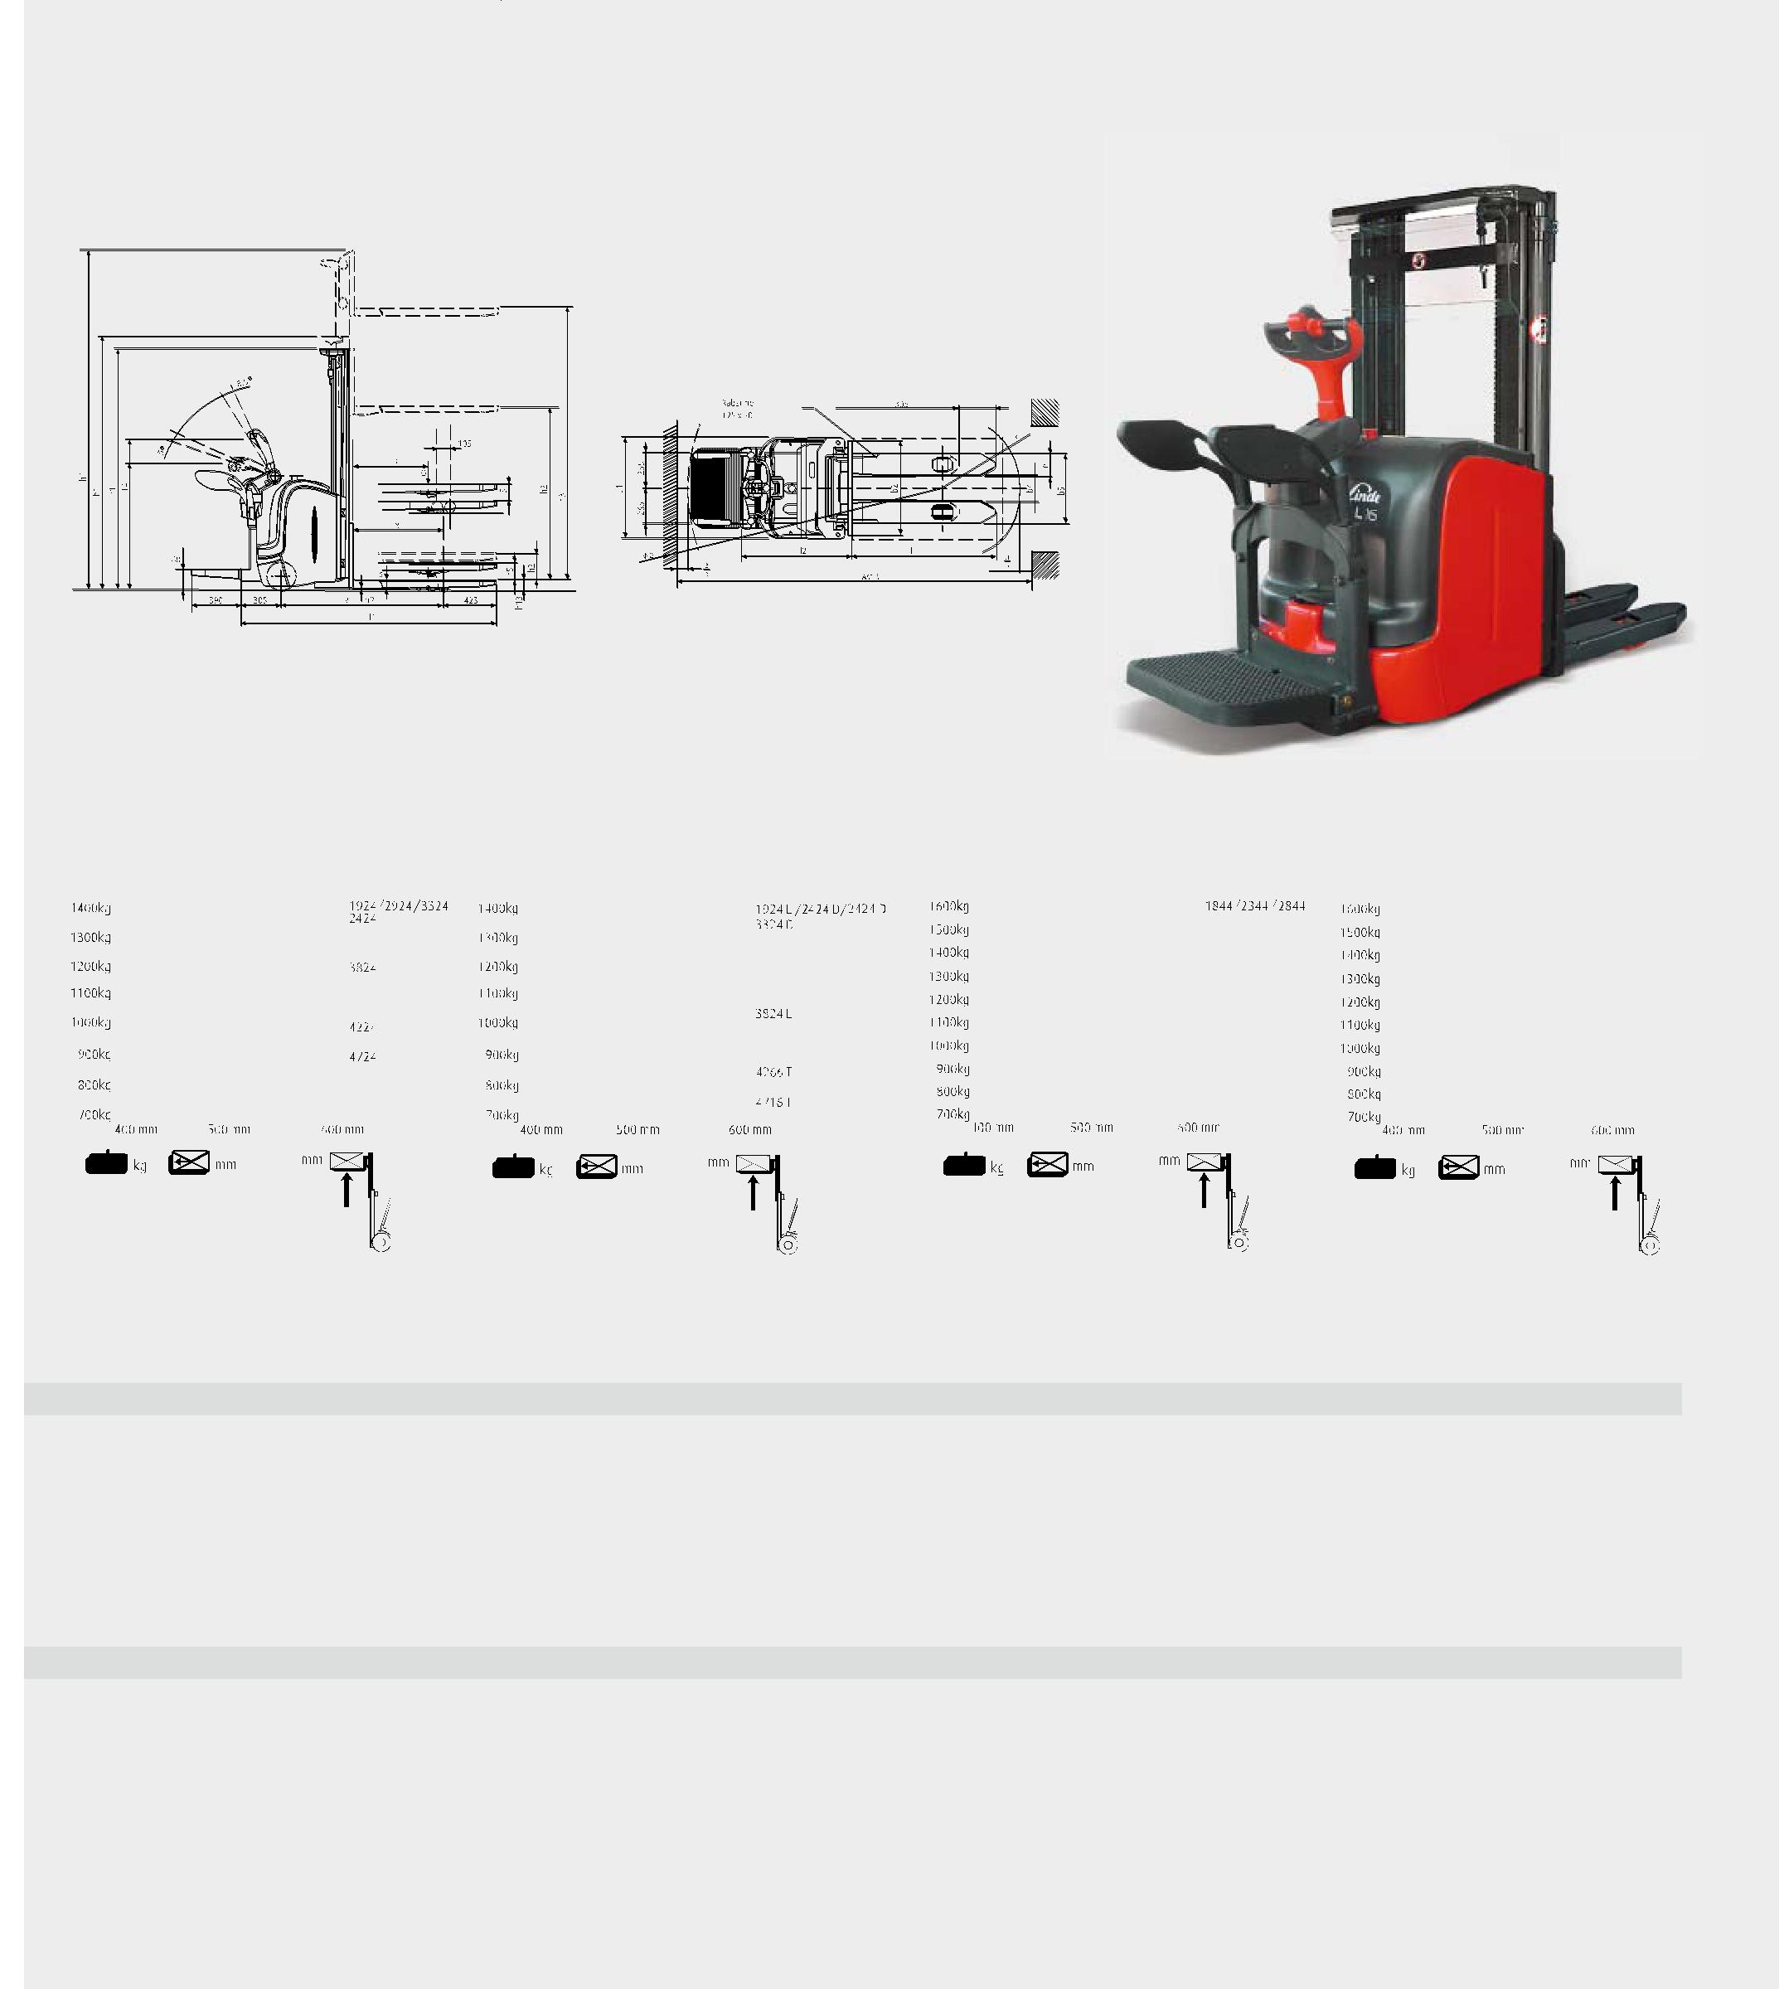

(D/T) | (S)

转弯半径 Ast=Wa+r+a 安全距离 a=200mm

Tuining radius Ast=Wa+r+a safety distance a=200mm

L14AP-560 标准门架 |  |  |  |  | L14AP-560 二级/三级门架 |  |  |  |  |  | L16AP-560 标准门架 |  |  |  |  |  | L16AP-560 二级/三级门架
L14AP-560 S mast |  |  |  |  | L14AP-560 D/T mast |  |  |  |  |  | L16AP-560 S mast |  |  |  |  |  | L16AP-560 D/T mast
 |  |  |  |  |  |  |  |  |  |  |  |  |  |  |  | 3244 |  |  |  |  |  | 1844D/2344D/2844D
 |  |  |  |  |  |  |  |  |  |  |  |  |  |  |  |  |  |  |  |  |  | 3244D
 |  |  |  |  |  |  |  |  |  |  |  |  |  |  | 3744
 |  |  |  |  |  |  |  |  |  |  |  |  |  |  |  | 4144 |  |  |  |  |  | 3744D
 |  |  |  |  |  |  |  |  |  |  |  |  |  |  | 4644 |  |  |  |  |  |  | 4266T
 |  |  |  |  |  |  |  |  |  |  |  |  |  |  |  |  |  |  |  |  |  | 4716T

门架参数表 Mast Datasheet (in: mm)

门架 Masts (in mm) |  | L14 | 1924S | 2424S | 2924S | 3324S | 3824S | 4224S | 4724S | 1924D | 2424D | 2924D | 3324D | 3824D | 4224D | 4266T | 4716T
门架提升高度 | Lift | h3 | 1924 | 2424 | 2924 | 3324 | 3824 | 4224 | 4724 | 1924 | 2424 | 2924 | 3324 | 3824 | 4224 | 4266 | 4716
货叉提升高度 | Lift+fork height | h₃+h₁₃ | 2010 | 2510 | 3010 | 3410 | 3910 | 4310 | 4810 | 2010 | 2510 | 3010 | 3410 | 3910 | 4310 | 4352 | 4802
回收高度 | Height, lowered | h1 | 1490 | 1740 | 1990 | 2190 | 2440 | 2640 | 2890 | 1415 | 1665 | 1915 | 2115 | 2365 | 2565 | 1915 | 2065
作业最大高度 | Height, extended | h₄ | 2460 | 2960 | 3460 | 3860 | 4360 | 4760 | 5260 | 2460 | 2960 | 3460 | 3860 | 4360 | 4760 | 4802 | 5252
自由提升高度 | Free lift | h₂ | 150 | 150 | 150 | 150 | 150 | 150 | 150 | 862 | 1212 | 1462 | 1662 | 1912 | 2112 | 1379 | 1529
门架 Masts (in mm) |  | L16 | 1844S | 2344S | 2844S | 3244S | 3744S | 4144S | 4644S | 1844D | 2344D | 2844D | 3244D | 3744D | 4144D | 4266T | 4716T
门架提升高度 | Lift | h3 | 1844 | 2344 | 2844 | 3244 | 3744 | 4144 | 4644 | 1844 | 2344 | 2844 | 3244 | 3744 | 4144 | 4266 | 4716
货叉提升高度 | Lift+fork height | h₃+h₁₃ | 1930 | 2430 | 2930 | 3330 | 3830 | 4230 | 4730 | 1930 | 2430 | 2930 | 3330 | 3830 | 4230 | 4352 | 4802
回收高度 | Height, lowered | h₁ | 1490 | 1740 | 1990 | 2190 | 2440 | 2640 | 2890 | 1415 | 1665 | 1915 | 2115 | 2365 | 2565 | 1915 | 2065
作业最大高度 | Height, extended | h₄ | 2380 | 2880 | 3380 | 3780 | 4280 | 4680 | 5180 | 2380 | 2880 | 3380 | 3780 | 4280 | 4680 | 4802 | 5252
自由提升高度 | Free lift | h₂ | 150 | 150 | 150 | 150 | 150 | 150 | 150 | 879 | 1129 | 1379 | 1579 | 1829 | 2029 | 1379 | 1529

其他规格门架根据需求提供。 Other masts on request.

